Comparison Report

Product 1 : Sauce Labs Backpack

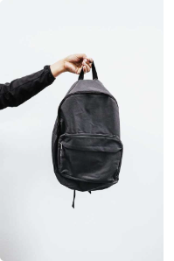

Price : $29.99

__________________________________________________________________________________________________

Product 2 : Sauce Labs Bolt T-Shirt

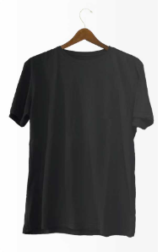

Price : $15.99

__________________________________________________________________________________________________